**Germanium**

*Space group*: Fd-3m, 227

*Lattice vectors*: *R*1 = (-*a*/2, 0, *a*/2); *R*2 = (0, *a*/2, *a*/2); *R*3 = (-*a*/2, *a*/2, 0)

*Atom positions*: Ge1 = (0, 0, 0); Ge2 = (*a*/4, *a*/4, *a*/4)

*Isotopes*: 20.38% 70Ge (69.924 amu); 27.31% 72Ge (71.922 amu); 7.76% 73Ge (72.923 amu); 36.72% 74Ge (73.921 amu); 7.83% 76Ge (75.921 amu)

*DFT*: Use VASP, QE, or both. PBEsol PAW, no *d* states in valence   
(QE: Ge.pbesol-n-kjpaw_psl.1.0.0.UPF; VASP: standard version with sol flag)

*Warning: DFT may give metallic. May need to check convergence with electronic smearing.*

**Checklist** (*all data should be reported for the 2-atom primitive cell*)

***Structure***

* Converged relaxed ‘temperature (T)=0’ lattice constant *a* (target accuracy < 0.005 Å)

- 5.6860 A

* Methods / convergence criteria

- vc-relax method

- convergence criteria, a reference energy value of ~ -320 was subtracted in the figure below.

*Figure 1 Potential Energy w.r.t to the lattice constant. The*

*Figure 2 Total energy w.r.t to the k-mesh size. To achieve a converged energy, a minimum k-mesh size of 20 is required. Occupations=”fixed” is used for Ge.*

*Figure 3 Total energy w.r.t to the ecutwfc*

*Figure 4 Total energy w.r.t the conv_thr*

*Table 1 converged parameters used for the calculation*

| Parameters | Converged values |
| --- | --- |
| k-mesh size | >= 20x20x20 |
| ecutwfc | >=40 |
| ecutrho | 4* ecutwfc |
| conv_thr | >=1e-6 |
| occupations | fixed |

From the energy vs lattice constant plot, the lattice constant that gives the minimum energy is 10.748 bohr (5.686 A)

* Other notes / cpu hours (*e.g., multiple relaxations, compilers, hardware*)
* 8.30s CPU 20.35s WALL with 64 core
* All input files to run fully converged calculations (*e.g., qe.sc.in, POSCAR*)
* See the file in the folder

***Electrons***

* Converged electron band dispersion (target accuracy < 0.1 eV for Γ/X/L frequencies)

- Numerical data: normalized wavevectors (q) and band energies (E): 4 valence bands and 6 conduction bands (excel or text file)

- q in units of 2π/*a* and f in eV

- 3 segments: Γ→X, Γ→K→X, and Γ→L evenly divided with ~100 q points per segment

- 3 files, one for each segment. For each scaled q from 0 to 1 list (~100 rows): q, E1, E2, E3, E4, E5, E6, E7, E8, E9, E10

* Methods / convergence criteria

- Thresholds/ Integration mesh / grid shifting

- The values suggested in Table 1 also gives a converged band structure. The band structures are identical with further increasing in convergence criteria, and thus now shown here.

- We also found that grid shifting has no effect on the band structure.

* Evidence of converged band structure

- Band structure with varying integration meshes

* Other notes / cpu hours
  + scf calculation: 64 cores, 14.03s WALL time
  + nscf calculation: 5.69s WALL
* All input files to run fully converged calculations
  + scf.in
  + nscf.in

***Harmonic***

* Converged dispersion (target accuracy < 0.1 THz for Γ/X/L frequencies)

- Numerical data: normalized wavevectors (q) and frequencies (f) for 6 polarizations (*j*) (excel or text file)

- q in units of 2π/*a* and f in THz (f=ω/2π)

- 3 segments: Γ→X, Γ→K→X, and Γ→L evenly divided with ~100 q points per segment

- 3 files, one for each segment. For each scaled q from 0 to 1 list (~100 rows): q, f1, f2, f3, f4, f5, f6

* Converged harmonic interatomic force constants (IFCs)

- Standard format for code used (*e.g.*, QE, Phonopy)

* espresso.ifc2

- Will be supplied as supplemental material upon publication

* Methods / convergence criteria

- Using the DFPT method to calculate the phonon dispersion

- Thresholds

* Same as electron band structure, the values in Table 1 are enough to achieve converged phonon dispersion. Furthering increasing the parameters give an identical phonon dispersion.

- Supercell size / integration mesh:

* A shifted grid is required for the scf calculation. Otherwise, it will give some errors.

- Symmetries / irreducibility / number of calculations (*linked to cpu hours below*)

- Post-processing (*e.g., enforce invariance constraints*)

* Evidence of converged dispersion

- Dispersions with varying supercell sizes and integration meshes

*Figure 5 Frequency of highest optical mode at G, X, and L points at different k mesh size*

*Figure 6 convergence with respect to the conv_thr in the scf calculation*

*Figure 7 convergence of the phonon frequency with respect to the th2_ph parameters in the phonon calculation.*

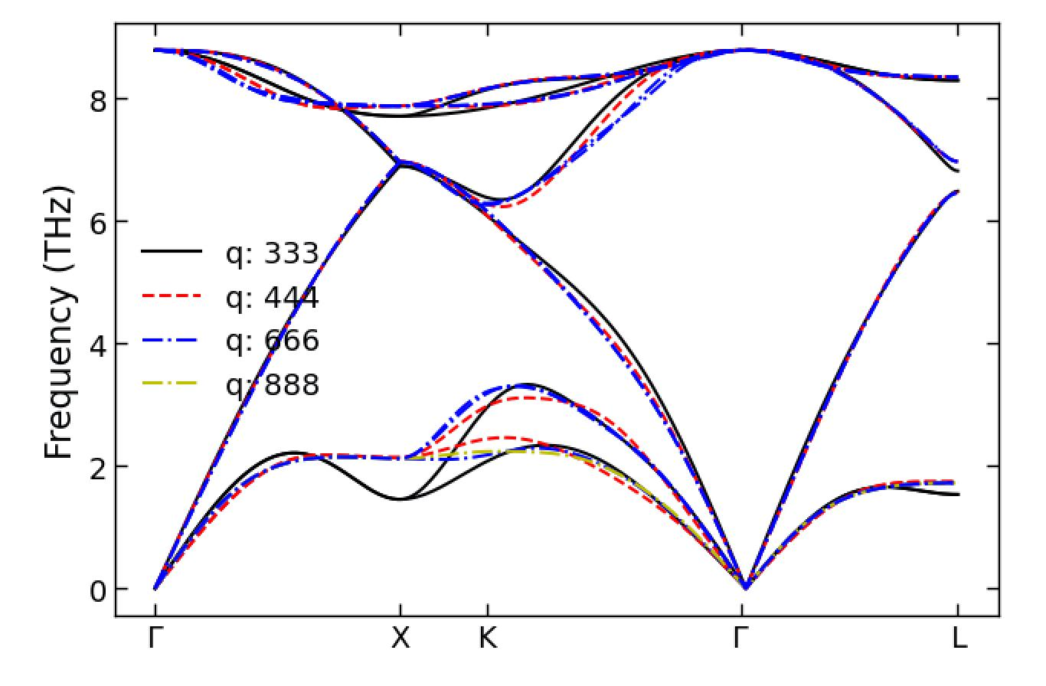

*Figure 8 Phonon dispersion with croase q mesh of 3x3x3, 4x4x4, 6x6x6 and 8x8x8 in ph calculation. As a compromise between interpolating accuracy and speed, we used a q mesh of 6x6x6.*

* Other notes / cpu hours (*e.g., accuracy vs cpu cost, shifted meshes*)
  + 128 cores, 10m58.91s WALL time for 3x3x3 q mesh grids
  + 128 cores, 18m58.35s WALL time for 4x4x4 q mesh grids
  + 128 cores, 1h22m WALL time for 6x6x6 q mesh grids
* All input files to run fully converged calculations
  + scf.in
  + ph.in
  + q2r.in
  + matdyn.in.freq

***Anharmonic thermal transport***

* Four converged T-dependent thermal conductivities (*k*): natural isotopes with full BTE solution (*knat,full*), natural isotopes with the relaxation time approximation (RTA) (*knat,RTA*), isotopically pure (100% 70Ge (69.924 amu)) with full BTE solution (*kpure,full*), and isotopically pure with RTA (*kpure,RTA*). If only RTA available, then only *knat,RTA* and *kpure,RTA*

- Do not include boundary scattering, even at low T. We want to see how the codes behave at low T without this extrinsic scattering.

- Numerical data: T (K) and *k* (W/m/K) in range 10K < T < 1000K (excel or text file)

- For 10K ≤ T ≤ 50K increments of 10K (5 data points); for 50K < T ≤ 300K increments of 25K (10 data points); for 300K < T ≤ 1000K increments of 100K (7 data points).

- 1 file with T from 10K to 1000K list (22 rows): T, *knat,full*, *knat,RTA*, *kpure,full*, *kpure,RTA*

* Accumulated T=300K *kacc* vs frequency and *kacc* vs mean free path (mfp) for converged *knat,RTA* value

- Numerical data for each mode (q, *j*) sampled in the Brillouin zone integration: f (THz), mfp=|sqrt(*vx*2+*vy*2+*vz*2)×lifetime| (nm), mode contribution to *k* (W/m/K) for *knat,RTA*

- 1 file (excel or text) with row for each mode (q, *j*): f, mfp, mode contribution to *k*

* RTA T=300K three-phonon scattering rates (1/*τ3ph*) and phonon-isotope scattering rates for natural abundance (1/*τiso*)

- Numerical data: f (THz), 1/*τ3ph* (THz=1/ps), and 1/*τiso* (THz)

- 1 file (excel or text) with row for each mode (q, j): f, 1/*τ3ph*, 1/*τiso*

* Converged third-order anharmonic IFCs

- Standard format for code used

- Will be supplied as supplemental material upon publication

* Methods / convergence criteria: thermal conductivity

- Delta function representation (*with details; e.g., adaptive smearing, cutoff*)

- Integration grid

- Symmetries used

* Methods / convergence criteria: anharmonic IFCs

- Cutoff radius, supercell size, integration mesh, thresholds, displacement parameter for supercell derivatives

- Post-processing

* Evidence of converged *k* at T=300K

- Varying integration meshes

*Figure 9 thermal conductivity with different conv_thr values*

*Figure 10 Thermal conductivity at different k-mesh values*

*Figure 11 Thermal conductivity at different displacement magnitude value*

*Figure 12 Thermal conductivity at different ecutwfc values*

* Other notes / cpu hours
  + There are 23 displacement patterns, and it takes about 128 cpu*hours for each displacement pattern.
  + The total computational costs are: 3000 cpu*hours
* All input files to run fully converged calculations
  + scf.in
  + alm.333.in
  + run_pw.sh
  + run_RTA.sh
  + alm.333.optimize.in
  + Ge333_cubic.xml